Lulzbot TAZ 5/6 Y Axis Linear Rail   
Conversion Instructions

IF DURING ANY POINT OF INSTALLATION YOU HAVE QUESTIONS, CALL OR EMAIL US BEFORE MOVING TO NEXT STEP.

First. Unplug the printer. Then, remove the 4 thumbscrews that hold your bed down to the printer. Then unplug the Y axis motor, Bed heater, thermistor and switch wiring. Remove the entire bed assembly from the printer and place in an easy to work in space.

Remove the 4 bed washers, screws and spacers from the bed assembly. Remove the build plate and set it aside somewhere safe. Turn the bed assembly upside down so you can see the bushing holders. Remove the 4 M3x8 button head screws that hold down each bushing holder and save the screws and washers as you will use these screws to mount the drill jig to the aluminum plate (shown in the images). Remove the 4 M3x8 button head screws and washers that hold down the Belt Mount. Remove the 4 M3x8 button head screws and washers that hold the Y End Idler on the front Y End Plate. Remove the 4 M3x8 button head screws and washers that hold on the Y End Motor Mount to the rear Y End Plate.

Mount the supplied 3D printed drill jigs to the aluminum bed plate with the M3x8 button head screws and washers you removed in the previous step. 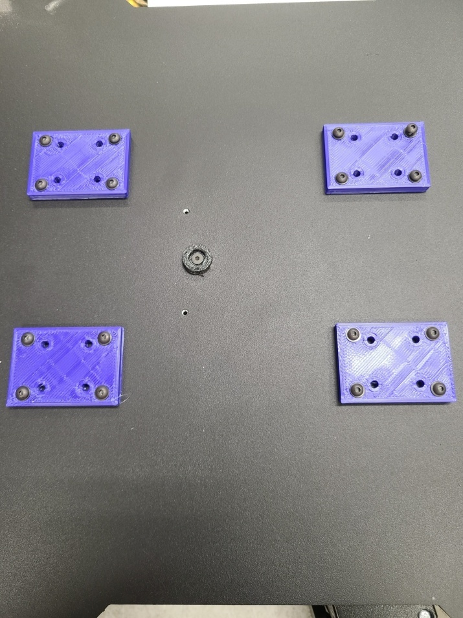

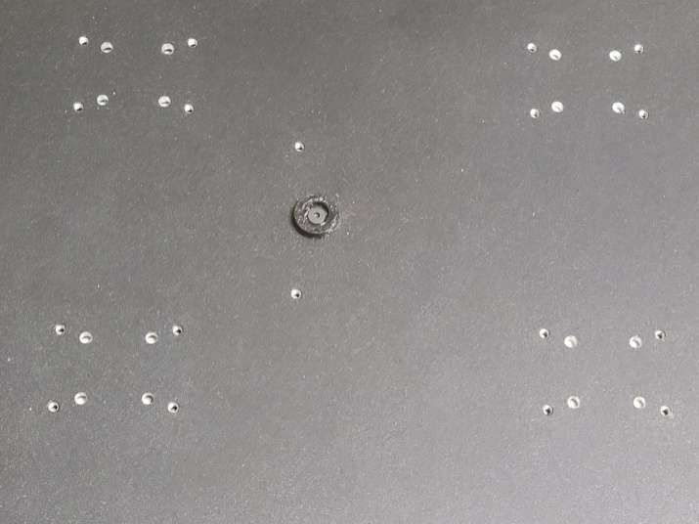Place the aluminum bed plate on something flat like a piece of plywood. This will ensure you do not bend the aluminum plate. Drill each hole out with the supplied 9/16” drill bit. Now remove the drill jigs and deburr each hole drilled with a larger drill bit by hand spinning the bit just over each hole You want the hole free of anything sticking off of it so the linear rail carriage mounts flush.

Loosen the set screws that hold the smooth rods onto the 3d printer corners and remove them from the assembly. You can put the bushing holders back onto the rods and set them aside for storage. Remove the M5x10 button head screws and washers from the Y end plates from the bed assembly being sure to keep all hardware. Remove the M5x10 button head screws and washers holding the 3d printer corners/bed feet again keeping the hardware as it will go back in its original position. Set your 20x20 Extrusions aside for later use.

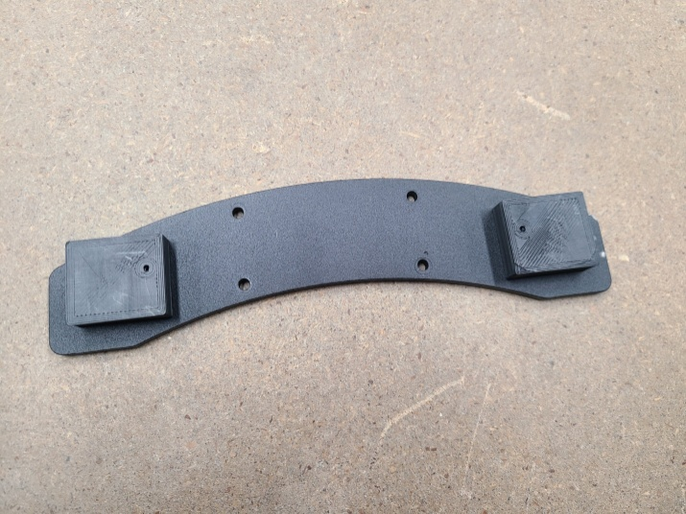Now, you will need to drill out the Y End Plates to accept the 4 new additional M3x8 button head screws. IMPORTANT: Refer to the photo included to ensure correct positioning of the drill jig. Using the supplied drill jig and same drill bit used before, drill out one hole on each side of both the front and rear Y End Plates. Deburr the holes as necessary.

Remove the rubber feet from your old Bed Corners, and move them to the new Bed Corners. Take your original 20x20 Extrusions and put them into the 4 3d printed corners.

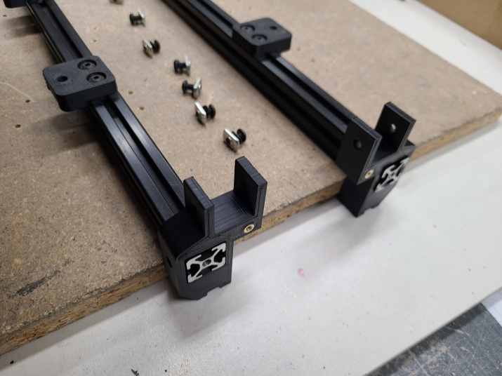To ensure correct positioning, please refer to the photo.

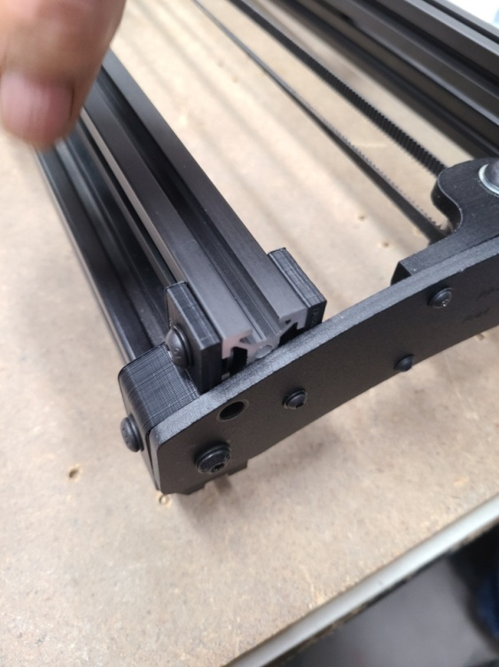Make sure all your T- Nuts are in the original position. Locate the 20x20 Extrusions supplied in the kit and insert the 2 slide-in M5 T-Nuts supplied into each 20x20 Extrusions ends. Install both 20x20 Extrusions into the 3d printed corners. Refer to the photo for the correct location of the button head screws, washers and T-Nuts. Again, loosely fit the M5x10 button head screws and washers into the ends of the extrusions and through the Y End Plates. This will greatly aid in the rail alignment needed in a future step.

Install both Y End Plates with 4 M5x10 button head screw and washer onto the 3D printed corner but keep it loose for now. Also install the M3x8 button head screw and washer into the newly drilled hole, but keep it loose for now. Install the Y End Motor Mount and Y End Idler back onto the Y End plates using the M3x8 button head screws and washers you removed from them in earlier steps. NOTE: You may find it beneficial to route the belt over the motor gear during installation. Once in position, tighten only these screws.

Remove the linear rails from their packaging. You will need to clean the shipping residue from each rail. You can use isopropyl alcohol or any light solvent cleaner and a paper towel. Clean the bottom side of the carriages (where you see the ball bearings) as well. Be careful not to let the carriages fall off the rails or the ball bearings will fly out and will most likely never be found. Make sure the carriages move freely on the rails, as it will be harder to correct this later. You will lubricate these at the end of the installation.

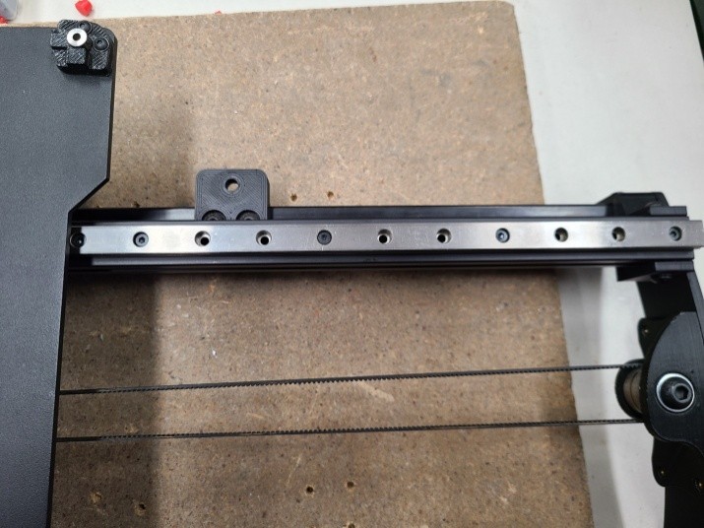Place the Bed Rail Assembly right side up on the work surface. In the next step you will install 8 each M3x8 cap head screws and drop-in T-Nuts onto the linear rails. See photo.

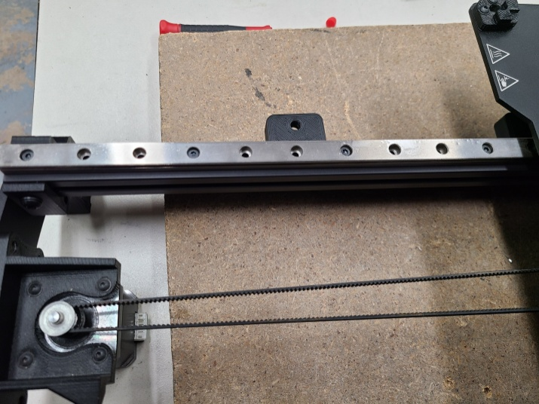It helps if you 1st place the M3x8 cap head screw into the linear rail, and then attach the drop-in T-Nut to it. After you have attached all of your screws and t nuts, turn the t-nuts so they face with the opening of the rail so they will drop into the Extrusion. After all of these are in place, you can position the linear rails over the Extruder rails, drop them in, and loosely tighten them.

Take your Aluminum Bed Plate and place the Linear Rails Carriage side to the bottom 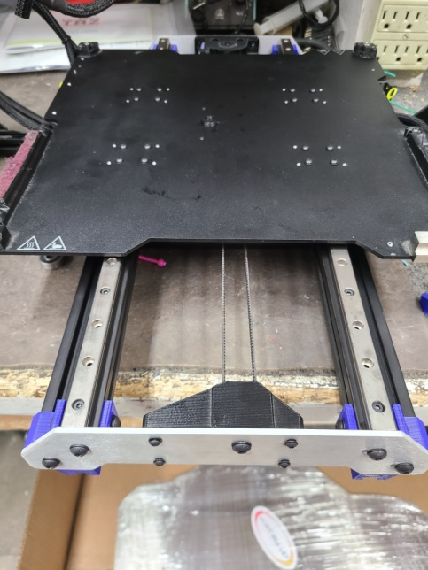of the Bed Plate and line up your holes to the holes you drilled in previous steps. Loosely install the 16 each M3x6 button head screws and washers. Do not fully tighten them. If they are too tight the linear rails will bind up, and right now they need to be loosely fit. They will need to be just tight enough to hold everything in place. You will have to play with this a bit to find the right tension in the final steps.

Loosely tighten the screws on the rail. When you start to tighten the screw, the t-nut will turn and grab the Extrusion. If you feel it doesn’t, unscrew your cap screw and try again until it grabs just a bit.

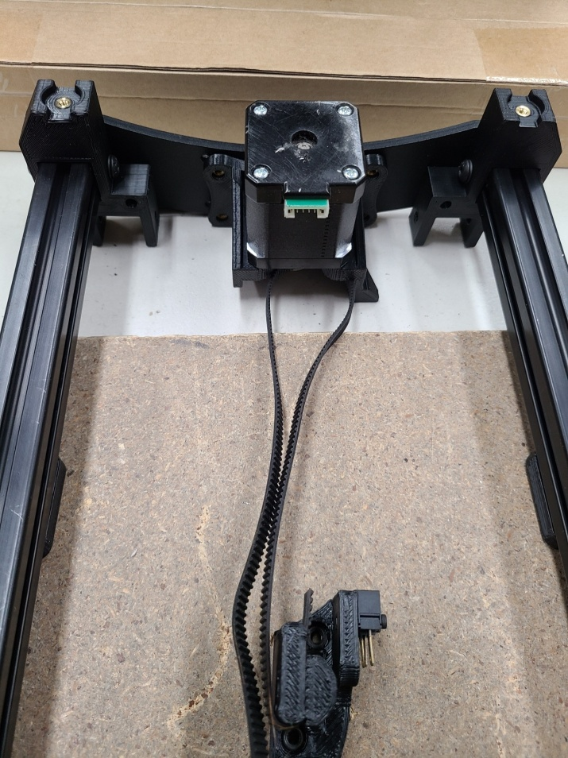Now that you have your Bed Plate and Linear Rails attached to the Y axis you are almost done!! Reattach the belt tensioner mount to the Bed Plate using the 4 M3x8 button head screws and washers. Reattach the orange 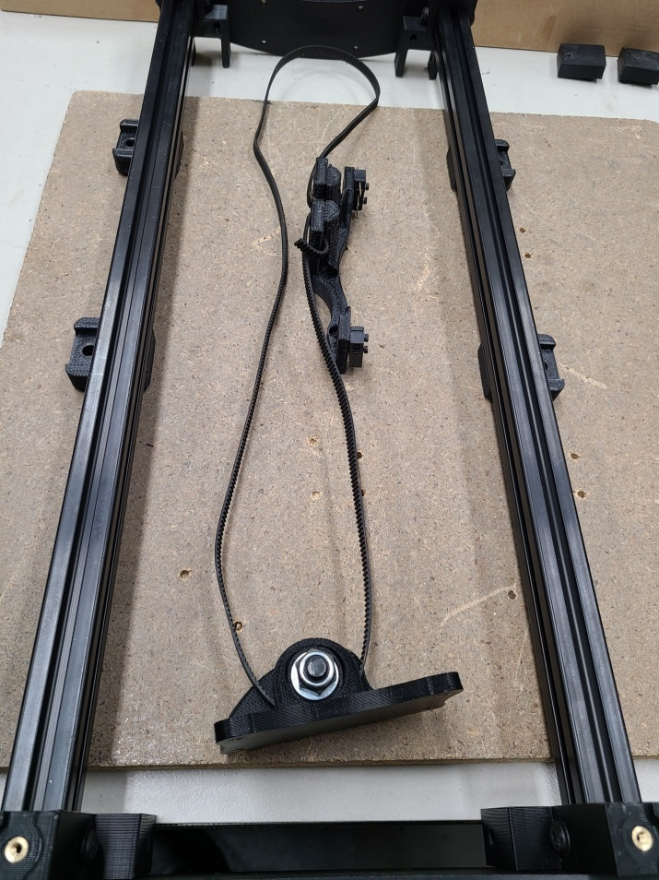and blue wires to their corresponding switches. Re-attach the Y Axis to your printer and install the Y Axis thumbscrews. At this point, you will want to to tighten all screws down gently. Do not over tighten any of the screws, just make them snug. You will find that you may have to loosen and tighten things to get the rails to align to your liking. Once you have everything moving freely, you can install your Heated Bed back onto the Bed Plate and plug in the Y Axis Motor. Be sure you don’t try to move the bed back and forth manually with speed or you may back feed electricity into your LED Board and cause damage. Turn on your printer and home the axis to make sure everything moves as it should.

You will want to treat your Linear Rails with a low viscosity lubricant. Do not use graphite. Tri-Flow lubricant works well and doesn’t attract dust. It is a bit pricey but works well. You can use any silicone based lubricant as long as it doesn’t attract too much unwanted dust or debris.

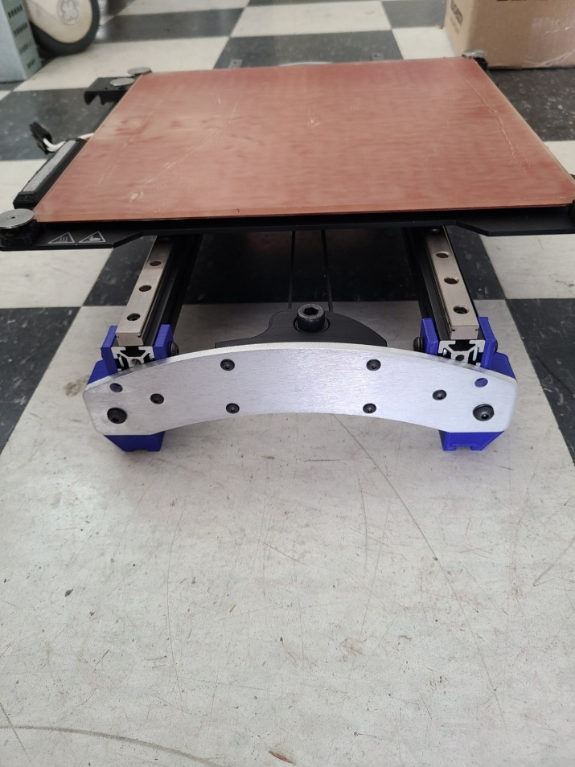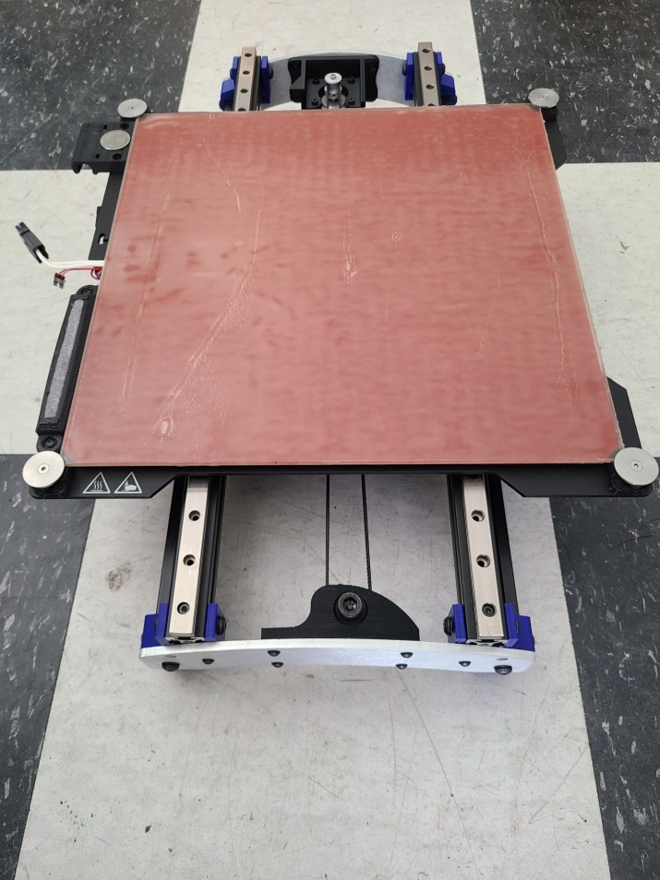

You are now finished with your Linear Rail Conversion!!!

If you have any questions, please email us at info@itworks3d.com.